Leetcode Problems & Solutions with Explanation DSA - II

- Palindrome Linked List (https://leetcode.com/problems/palindrome-linked-list/):
- Solution Link: https://leetcode.com/problems/palindrome-linked-list/submissions/1815783005
- Time Complexity: O(n)
- Space Complexity: O(1)
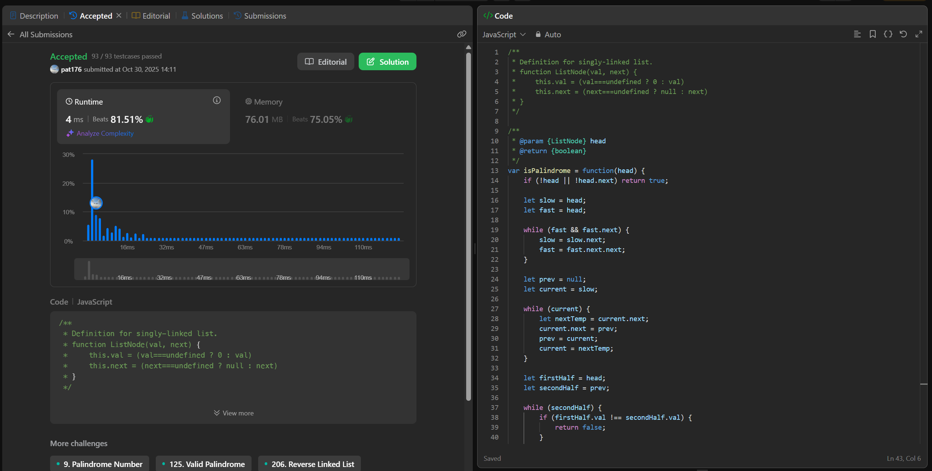

- Remove Nth Node from End of List (https://leetcode.com/problems/remove-nth-node-from-end-of-list/):
- Solution Link: https://leetcode.com/problems/remove-nth-node-from-end-of-list/submissions/1815792155
- Time Complexity: O(n)
- Space Complexity: O(1)
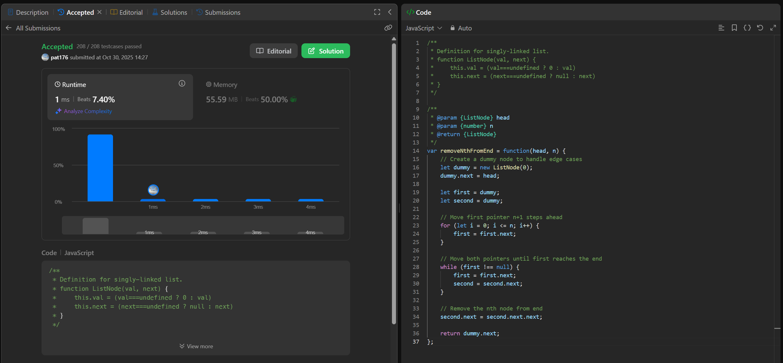
- Valid Parentheses (https://leetcode.com/problems/valid-parentheses/):
- Solution Link: https://leetcode.com/problems/valid-parentheses/submissions/1815793690
- Time Complexity: O(n) - Single pass through the string
- Space Complexity: O(n) - Stack can grow up to n in worst case
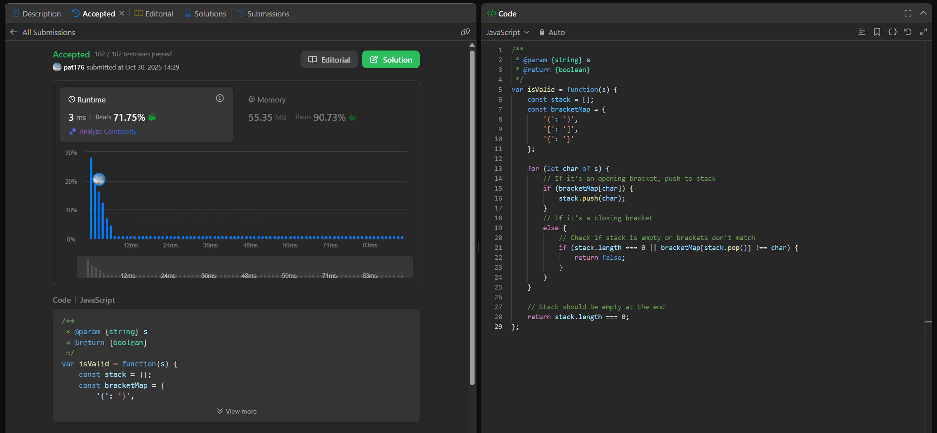
- Next Greater Element I (https://leetcode.com/problems/next-greater-element-i/):
- Solution Link: https://leetcode.com/problems/next-greater-element-i/submissions/1815795706
- Time Complexity: O(n + m)
- Space Complexity: O(n)
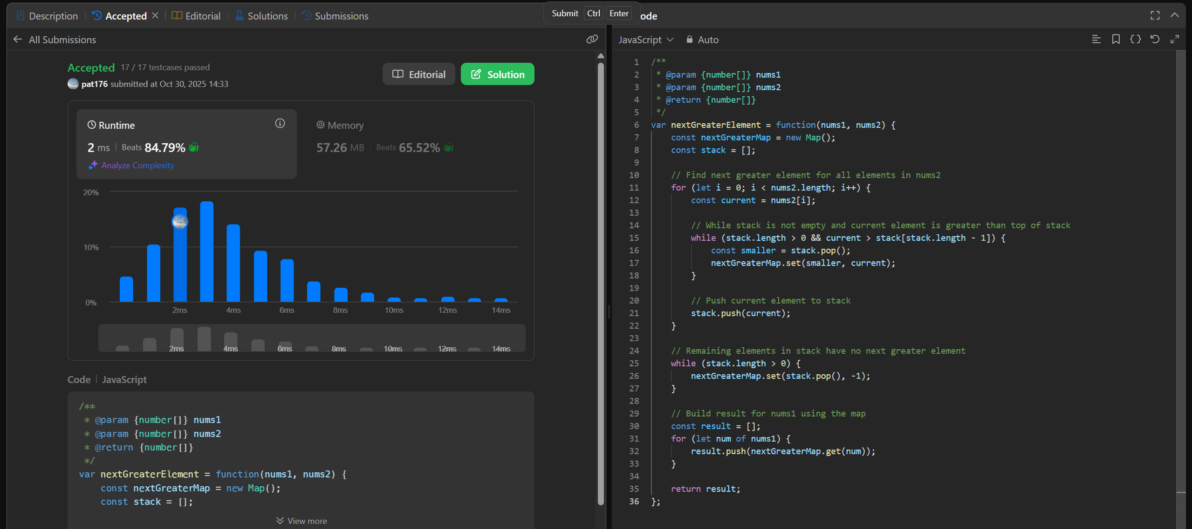

- Minimum Depth of Binary Tree (https://leetcode.com/problems/minimum-depth-of-binary-tree/):
- Solution Link: https://leetcode.com/problems/minimum-depth-of-binary-tree/submissions/1815797248
- Time Complexity: O(n)
- Space Complexity: O(h)
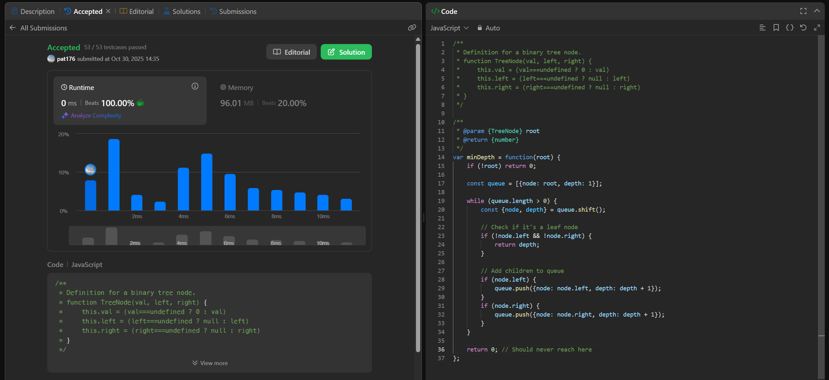

- Binary Tree Post Order Traversal (https://leetcode.com/problems/binary-tree-postorder-traversal/):
- Solution Link: https://leetcode.com/problems/binary-tree-postorder-traversal/submissions/1815798745
- Time Complexity: O(n)
- Space Complexity: O(n)
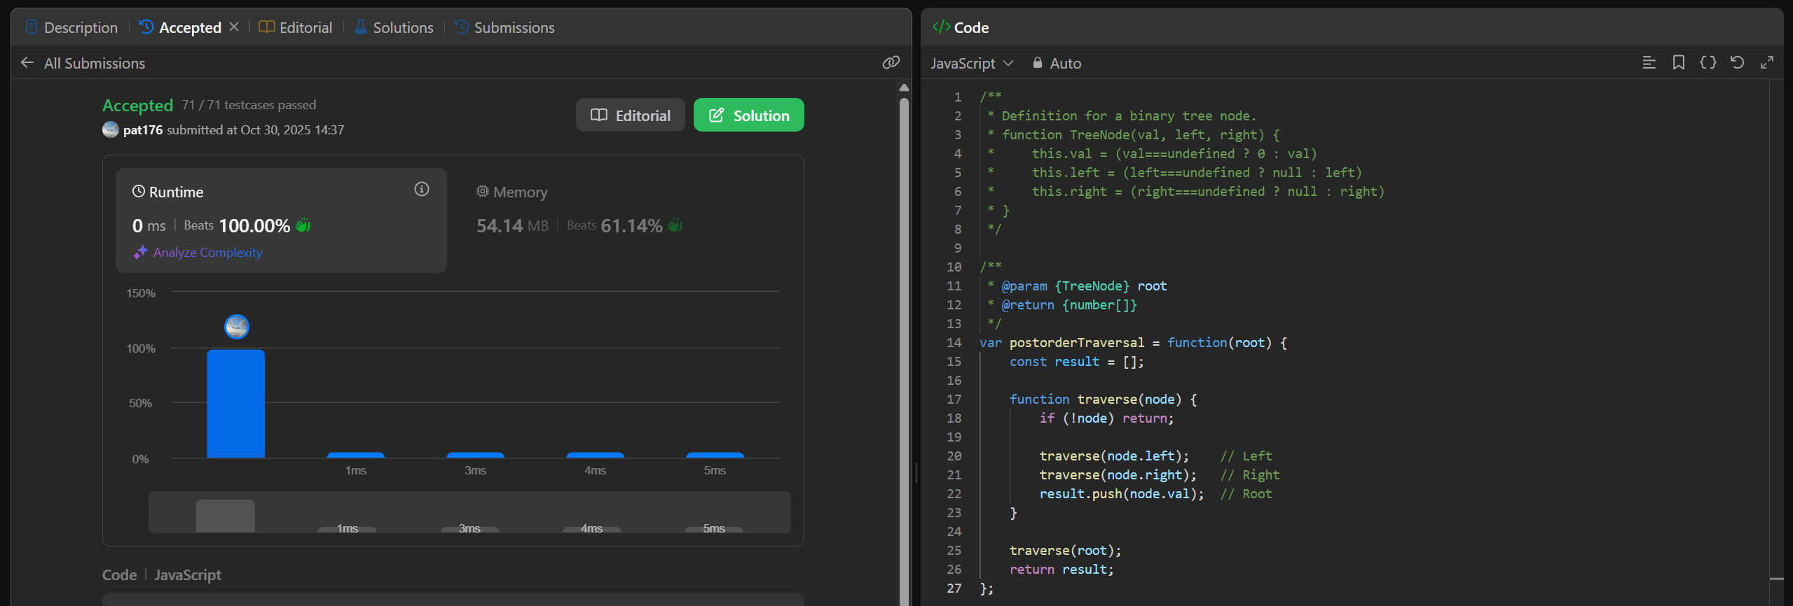

- Delete Node in a Linked List (https://leetcode.com/problems/delete-node-in-a-linked-list/):
- Solution Link: https://leetcode.com/problems/delete-node-in-a-linked-list/submissions/1815800274
- Time Complexity: O(1)
- Space Complexity: O(1)
